Important Flexible Spending Account Information

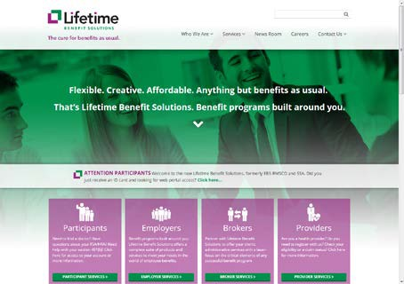
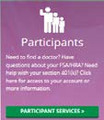
As part of St. Lawrence University’s FSA program, you have access to your account… 24 hours a day, 7 days a week. You can access your account online at www.LifetimeBenefitSolutions.com.

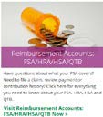
Click on the Participants link at the bottom of the page.

Select Reimbursement Accounts: FSA/HRA/HSA/QTB

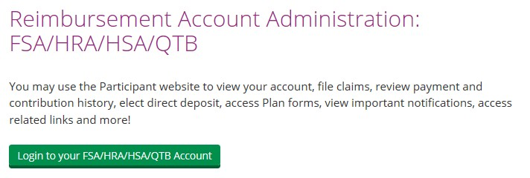
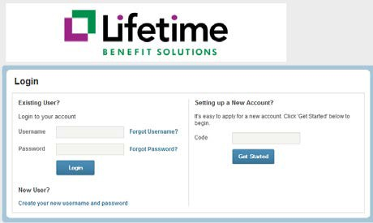
Click the green button to get to the log in page.

Your initial username will be your SLU ID Number (located on your SLU ID Card). Your password will be the first letter of your first name (lower case) followed by your 5- digit zip code. If you are a dependent of the employee, you must use the employee’s information to log in.
For example - - employee John Smith, SLU ID #6055555, will login with a username of 6065555 and a password of j13617(the lower-case “j” is from his first name and 13617 is his zip code).
If this is your first entry to the site, you will be required to change your password. You will also be asked to set up security questions.

From this site, you will be able to:
• File claims online (with an option to scan and attach your receipts, or fax/mail them)
• Update your email address, username, and password
• Manage notification letters from Lifetime Benefit Solutions
• View your account summary and track account contributions and payments
• Complete Plan-related forms directly online, then print, and submit for processing

Direct Deposit: Avoid a trip to the bank and sign up for direct deposit. Simply enter your banking information into the Bank Accounts section of the Profile tab.

Email Address: It is essential that you maintain an updated email address at all times. Your email address will be used at Lifetime Benefit Solutions strictly for the purpose of communicating important Plan information.

Questions regarding your account can be directed to our Customer Service Department by phone at (800) 327-7130 or by email at lbs.customerservice@lifetimebenefitsolutions.com.

