New User Login Instructions
Online Recruitment & Applicant Tracking System

http://employment.stlawu.edu/hr

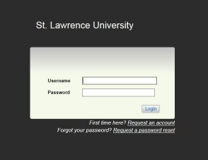
Log in with your username (first initial and last name) and same for initial password

You will be prompted to change your password after your first login attempt.
Note: If you have multiple views in the system (Hiring Manager, Search Committee Member, Search Chair) make sure you are logged in as Search Committee Member.
